# Using Light Blue Bean to Teach Coding

Coding can be very complex but like math, progressing through each stage can be taught in steps. Light Blue Bean is the perfect tool to teach coding to novice users and for developing little minds.

## Internet of Things (IOT)

The IOT is a network that connects vehicles, buildings and other items that have network connectivity and allows them to communicate with one another. Basically, anything that connects to the internet either from a network signal or Bluetooth is included in the internet of things.

## Light Blue Bean

Light Blue Bean is a device that connects your physical hardware devices to the IOT network through Bluetooth technology. Light Blue Bean can be programmed wirelessly and can be placed into any inanimate object.

## Other IOT Devices That Teach Coding

Light Blue Bean isn’t the only IOT device on the market that can teach coding. There are an abundance of products that can help people learn how to code such as Arduino, Raspberry Pi and Netduino.

## Computational Thinking

The concept of computational thinking is essentially tricking the mind into thinking the way a computer thinks. Devices that teach coding will help people learn how to code by teaching them how to think like a computer. Computational thinking works in three processes:

1. Problem Formulation
2. Solution Expression
3. Solution Execution and Evaluation

Once a problem has been formulated the student will use their human thinking abilities to create a model that can solve the problem. The model is composed in a manner that allows a computational device to follow through with the solution. Developing the skills needed for computational thinking will allow the student to be successful in coding ventures using IOT devices.

## How to Use Light Blue Bean with the Tickle Application (App)

Light Blue Bean comes with a companion app that allows the user to control it but Light Blue Bean can also be controlled by other apps. One of the apps that is commonly used to control the Light Blue Bean is the Tickle App. The Tickle app has graphics that are appealing to children. With the application, you can choose funny little characters and make them move around and speak. To use Light Blue Bean with the Tickle app, complete the following steps:

1. Download and open the Tickle app.
2. Ensure that Light Blue Bean is in range of the device with the Tickle app installed.
3. Click on the **Light Blue Bean** icon to connect to the bean.

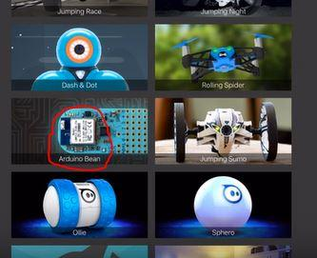

1. Click on **New Project** on the top right corner of the screen.

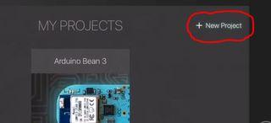

1. Click on **Add+**.

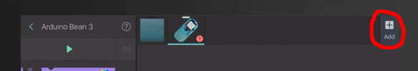

1. Click on the desired Character.
2. Scroll down to **Control**.
3. Select the **If Then** **Statement**.
4. Drag and drop the statement to the right section of the screen.

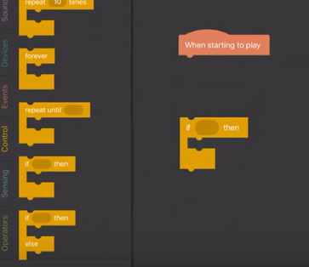

1. Scroll down to the **Sensing Range**.
2. Drag and drop a **Greater Than and Less Than Statement** into the **If Then Statement**.

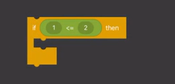

1. Enter a desired speed in both **Greater Than Slots**.
2. Scroll down to the device's code.
3. Drag and drop the **Accelerometer** into the **Less Than Slot.**

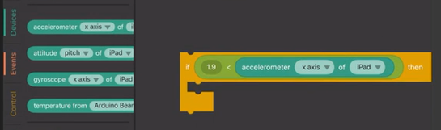

1. Click on the drop-down list that says **iPad** and select **Light Blue Bean**.
2. Drag and drop the command that you would like to happen when the desired speed is achieved (i.e. playing a sound).
3. Drag the **Looks Statement** to the **If Then Statement**.

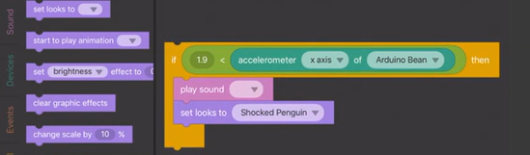

1. Click on the drop-down list and choose a reaction that you want your desired character to have when it reaches the desired speed.
2. Find the **If Then Else Statement** and use this statement if you would like something to happen to your character if it doesn’t reach the desired speed

**Note: If you are using the If Then Else statement you need to drag and drop all the elements from the if then statement into the if then else statement. Once all the elements from the if then statement are transferred, drag and drop the blank statement into the left side of the screen.**

1. Drag and drop a **Say Code** beside **Else**.
2. Change the text in the bubble to the phrase you want your character to say if it does not reach the desired speed.

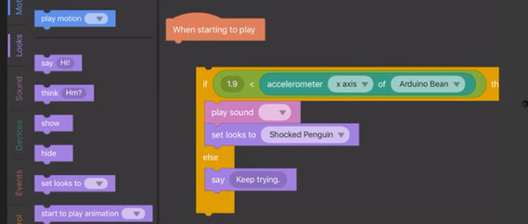

1. Select a **Wait Statement** and drag and drop it under the **Then Statement Line**.
2. Select a desired waiting time for the character to wait before it says the statement.
3. Drag the whole statement to join it to the **When Starting To Play Line**.

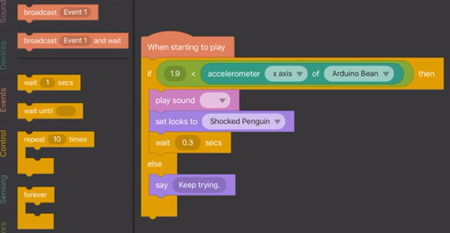

1. Select **Play**. Once the bean moves to a certain speed it will interact with the desired character and play a sound.

## The Downside of the IOT

Although the IOT is an amazing tool to connect wearable devices like the apple watch and GPS locators, there is a downside to it. There are hackers out there that can and will get into your IOT devices and shut them down or steal information. Always be aware of the networks that your device connects to and follow all security protocols.